**Classroom Activity​: Write a program to find the given string are equals or not using promise**

**HtmlCode:**

<!DOCTYPE html>

<html lang="en">

<head>

<meta charset="UTF-8">

<meta name="viewport" content="width=device-width, initial-scale=1.0">

<title>String Equality Check</title>

</head>

<body>

<input type="text" id="string1" placeholder="Enter first string">

<input type="text" id="string2" placeholder="Enter second string">

<button id="checkButton">Check Equality</button>

<p id="result"></p>

<script src="script.js"></script>

</body>

</html>

**Script code:**

// Function to compare two strings using a Promise

function compareStrings(string1, string2) {

return new Promise((resolve, reject) => {

if (string1 === string2) {

resolve('The strings are equal.');

} else {

reject('The strings are not equal.');

}

});

}

// Function to handle button click

function handleButtonClick() {

const str1 = document.getElementById('string1').value;

const str2 = document.getElementById('string2').value;

const resultElement = document.getElementById('result');

compareStrings(str1, str2)

.then(message => {

resultElement.textContent = message;

resultElement.style.color = 'green';

})

.catch(error => {

resultElement.textContent = error;

resultElement.style.color = 'red';

});

}

// Add click event listener to the button

document.getElementById('checkButton').addEventListener('click', handleButtonClick);

**Output:**

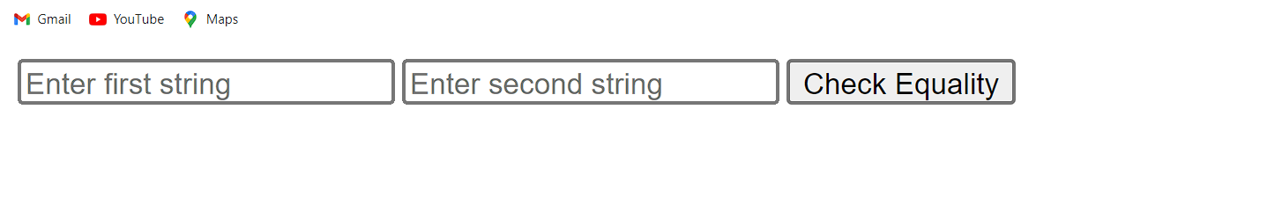

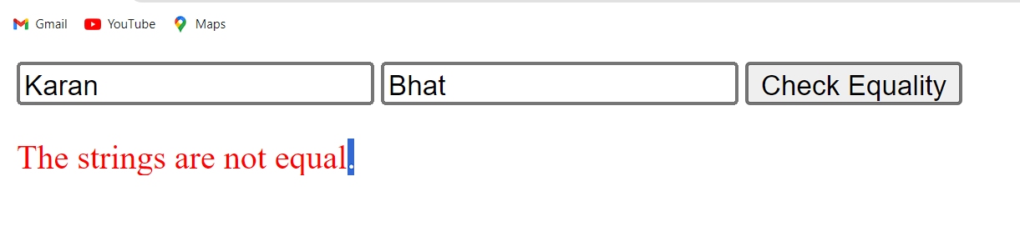

**Execution-Steps:**

* Create a JavaScript file with any name
* Write the code
* Run the code in the terminal using F5 or right click and go to inspect and you can get the output in the console as well.